Waheed Medical Store
Management System

Team Members: Senan Waheed & Zain Ali
Database Design Document — Entity Relationship Diagram (ERD)

Topic | Version | Prof Remarks | Date
ERD & Schema | Version 1.0 |  | April 26, 2026

1. Project Overview
The Waheed Medical Store Management System is a database-driven application designed to streamline the operations of a pharmacy or medical store. This document describes the database schema through an Entity Relationship Diagram (ERD), covering all entities, attributes, primary/foreign keys, and the relationships between them.
The system manages four core data entities: Suppliers, Medicines, Customers, and Sales. Together, these entities support inventory tracking, supplier management, sales processing, and customer records.

2. Entity Relationship Diagram
The diagram below provides a visual overview of all entities, their attributes, and the relationships connecting them.

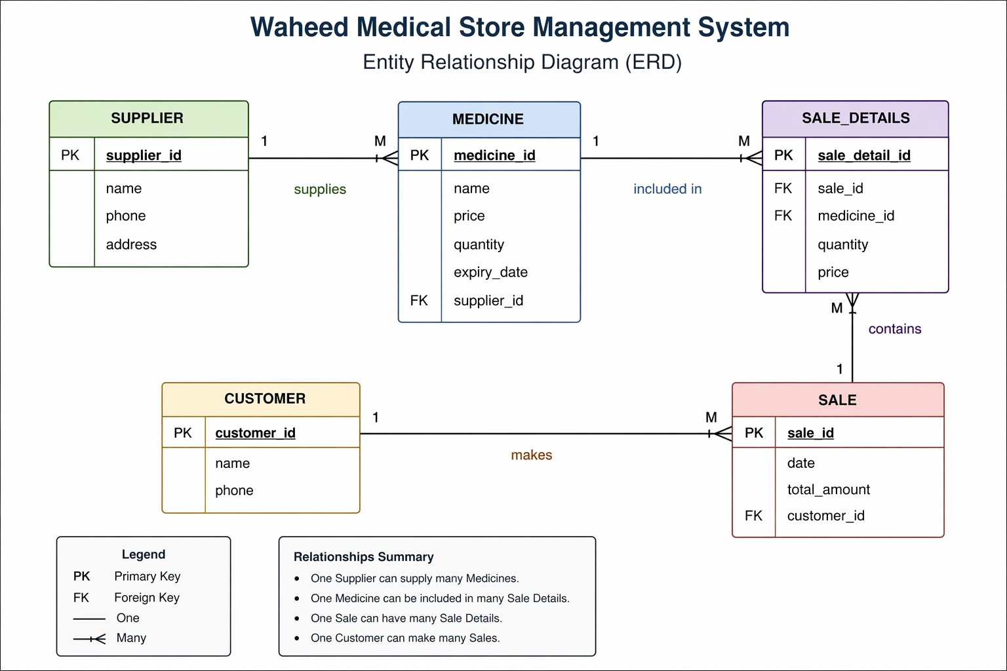
Figure 1: Waheed Medical Store Management System — ERD

3. ERD Summary — Entities and Attributes
The following section details each entity along with its attributes, key designations, and purpose within the system.

3.1 SUPPLIER
Stores information about medicine suppliers who provide stock to the medical store.

SUPPLIER
Key | Attribute | Description
PK | supplier_id | Unique identifier for each supplier
 | name | Full name of the supplier
 | phone | Contact phone number
 | address | Physical address of the supplier

3.2 MEDICINE
Contains the inventory of all medicines available in the store, including pricing, stock levels, and expiry information.

MEDICINE
Key | Attribute | Description
PK | medicine_id | Unique identifier for each medicine
 | name | Name/brand of the medicine
 | price | Unit selling price
 | quantity | Available stock quantity
 | expiry_date | Expiration date of the medicine batch
FK | supplier_id | References the supplying SUPPLIER

3.3 CUSTOMER
Holds basic contact information for customers who make purchases at the medical store.

CUSTOMER
Key | Attribute | Description
PK | customer_id | Unique identifier for each customer
 | name | Customer full name
 | phone | Customer contact number

3.4 SALE
Records each sales transaction, linking it to the customer and storing the transaction date and total amount.

SALE
Key | Attribute | Description
PK | sale_id | Unique identifier for each sale
 | date | Date the sale occurred
 | total_amount | Total monetary value of the sale
FK | customer_id | References the purchasing CUSTOMER

3.5 SALE_DETAILS
A junction/line-item table that captures the individual medicines included in each sale, along with quantity and price at time of sale.

SALE_DETAILS
Key | Attribute | Description
PK | sale_detail_id | Unique identifier for each line item
FK | sale_id | References the parent SALE
FK | medicine_id | References the MEDICINE sold
 | quantity | Number of units sold
 | price | Price per unit at time of sale

4. Relationships Between Entities
The ERD defines four key relationships between entities, each with One-to-Many (1:M) cardinality. These relationships are enforced through foreign key references.

Relationship | From | To | Description
supplies (1:M) | SUPPLIER | MEDICINE | One supplier can provide many medicines. Each medicine references one supplier via supplier_id FK.
included in (1:M) | MEDICINE | SALE_DETAILS | One medicine can appear in many sale detail records. Each line item references one medicine.
contains (1:M) | SALE | SALE_DETAILS | One sale can have many sale detail line items. Each detail references one sale via sale_id FK.
makes (1:M) | CUSTOMER | SALE | One customer can make many sales over time. Each sale references one customer via customer_id FK.

5. Relationship Summary
- One Supplier can supply many Medicines.
- One Medicine can be included in many Sale Details.
- One Sale can have many Sale Details.
- One Customer can make many Sales.

6. Legend
PK | Primary Key — uniquely identifies each record in a table
FK | Foreign Key — references a primary key in another table
1 | One side of a one-to-many relationship
M | Many side of a one-to-many relationship

Waheed Medical Store Management System — Database Design Document

